**Name & ID**: Syed Asghar Abbas Zaidi **Date:** 24th October 2023

| **EE-424L Data Communication & Networking**  **Fall 2023**  **Habib University**  **Dhanani School of Science & Engineering** |
| --- |



**LAB 8: Configuring General-purpose Network-Utilities**

| **Lab #11 Marks distribution:**   |  |  | **LR2=30** | **LR5=40** | **LR9=10** | **AR4=20** | | --- | --- | --- | --- | --- | --- | | **In-Lab Tasks** | **Task 1** | 05 | 10 | 10 | 20 | | **Task 2** | 05 | 10 | | **Task 3** | 10 | 10 | | **Task 4** | 10 | 10 | | **Total Marks** | **100** | | | | |   **Lab #11 Marks Obtained:**   |  |  | **LR2=30** | **LR5=40** | **LR9=10** | **AR4=20** | | --- | --- | --- | --- | --- | --- | | **In-Lab Tasks** | **Task 1** |  |  |  |  | | **Task 2** |  |  | | **Task 3** |  |  | | **Task 4** |  |  | | **Marks Obt.** |  | | | | | |
| --- | --- | --- | --- | --- | --- | --- | --- | --- | --- | --- | --- | --- | --- | --- | --- | --- | --- | --- | --- | --- | --- | --- | --- | --- | --- | --- | --- | --- | --- | --- | --- | --- | --- | --- | --- | --- | --- | --- | --- | --- | --- | --- | --- | --- | --- | --- | --- | --- | --- | --- | --- | --- | --- | --- |

| o**bjectives** | **The objective of this lab is to configure and verify different servers and understand the concept of NAT.** |
| --- | --- |

**Introduction**

**SMTP**

Simple Mail Transfer Protocol (SMTP) is the standard for email transmission across the Internet.   
SMTP is a relatively simple, text-based protocol, where one or more recipients of a message are specified (and in most cases verified to exist) and then the message text is transferred. It is quite easy to test a SMTP server using the telnet program.

**FTP**

FTP or file transfer protocol is a protocol used for exchanging files over the Internet. FTP works in the same way as HTTP for transferring Web pages from a server to a user's browser, and SMTP for transferring electronic mail across the Internet in that FTP uses the Internet's TCP/IP protocols to enable data transfer. FTP is most commonly used to download a file from a server using the Internet or to upload a file to a server (e.g., uploading a Web page file to a server).

**HTTP**

HyperText Transfer Protocol (HTTP) is the primary method used to convey information on the World Wide Web. The original purpose was to provide a way to publish and receive HTML pages.

**DNS**

The Domain Name System (DNS) is a system that stores information associated with domain names in a distributed database on networks, such as the Internet. The domain name system associates many types of information with domain names, but most importantly, it provides the IP address associated with the domain name. It also lists mail exchange servers accepting e-mail for each domain. DNS is useful for several reasons. Most well-known, the DNS makes it possible to attach hard-to-remember IP addresses (such as 207.142.131.206) to easy-to-remember domain names (such as "wikipedia.org.")

**NAT**

Network address translation (**NAT**) is the process of modifying IP address information in IP packet headers while in transit across a traffic routing device. There are two types of NAT.

**Static NAT**: The simplest type of NAT provides a one-to-one translation of IP addresses. It is often also referred to as one-to-one NAT. In this type of NAT only the IP addresses, IP header checksum and any higher level checksums that include the IP address need to be changed. The rest of the packet can be left untouched. Basic NATs can be used when there is a requirement to interconnect two IP networks with incompatible addressing.

**Dynamic NAT**: Dynamic NAT has some similarities and differences compared to static NAT. Like static NAT, the NAT router creates a one-to-one mapping between an inside local and inside global address and changes the IP addresses in packets as they exit and enter the inside network. However, the mapping of an inside local address to an inside global address happens dynamically. Dynamic NAT sets up a pool of possible inside global addresses and defines matching criteria to determine which inside local IP addresses should be translated with NAT. The dynamic entry stays in the table as long as traffic flows occasionally.

| **Task 1: SMTP Server** | **[15]** | |
| --- | --- | --- |
|  | |  |

**Building the Topology**

1. Move the devices (5 PCs, 4 servers, 1 switch and 1 router) into Topology area.
2. Select the appropriate connection type and connect them.
3. Re-write the server names and mention IPs as shown in below topology diagram.

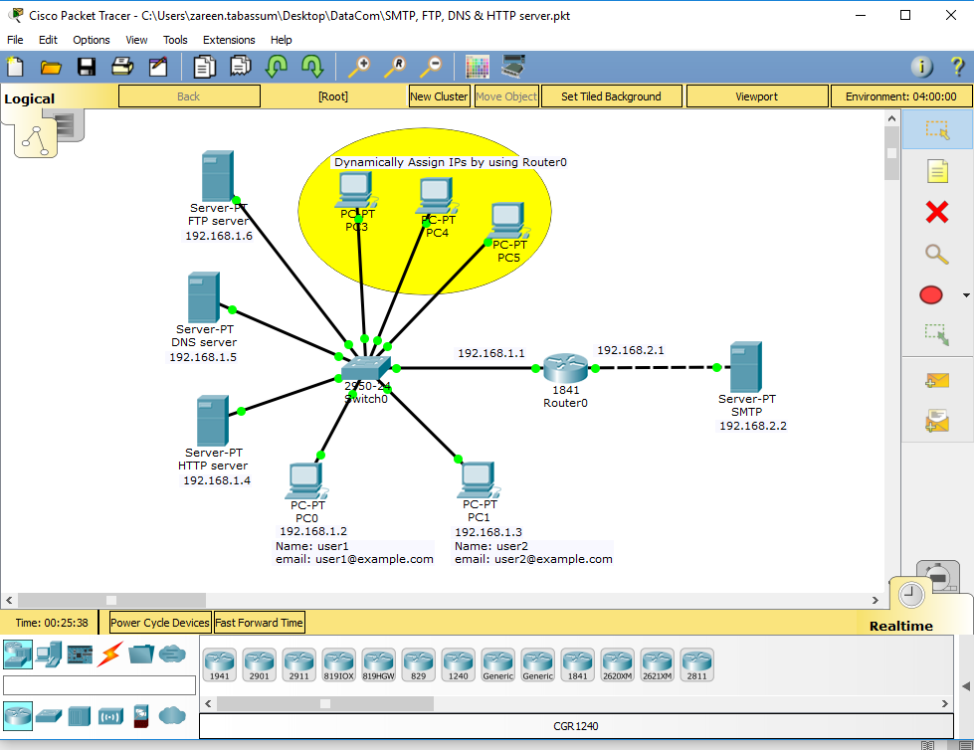

**Steps:**

1. Check the router interface and assign IP and subnet mask 192.168.2.1/24 to router’s interface i.e. connected with server. Similarly, assign 192.168.1.1/24 to router’s interface i.e. connected with switch.

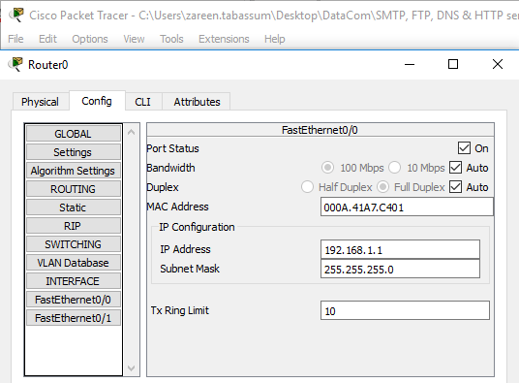

1. Click on SMTP server and assign below mentioned values.

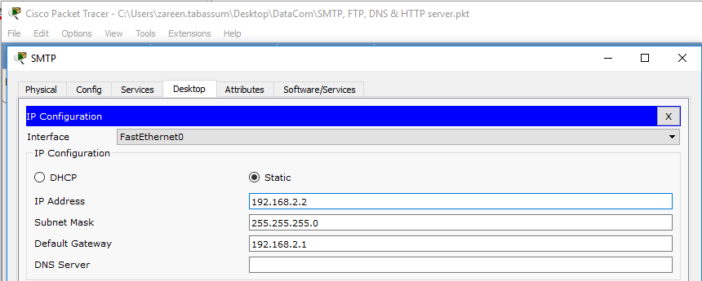

1. Go to services in SMTP server and click on **Email service. “**ON” SMTP and POP3 service. Write “example.com” in domain name and press set button.
2. Add two users in user setup.

**User**: user1

**Password:** 123and click on “+” button.

**User**: user2

**Password:** 123 and click on “+” button.

1. Assign IPs to PC0 and PC1 as given below.

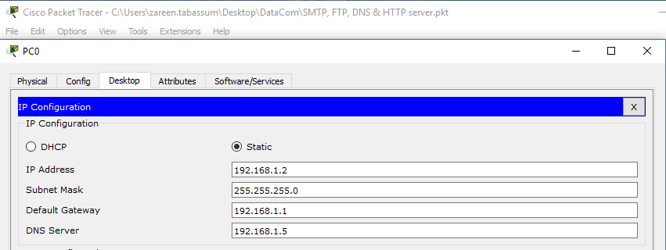

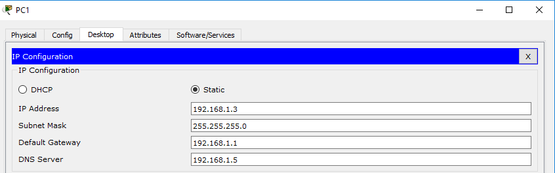

1. Now go to email in PC0 as given below.

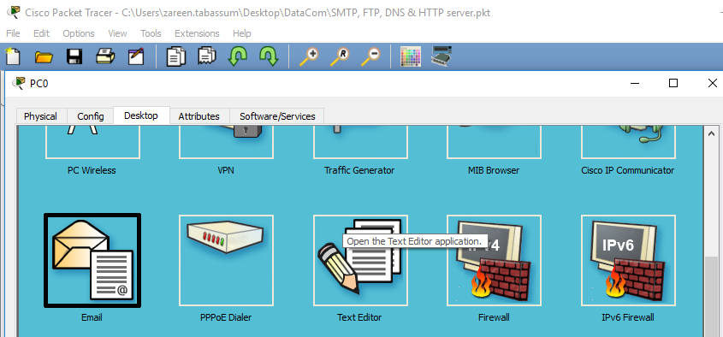

1. Click on email and go to configure email. Fill the name, email address, server information and login information as mentioned below and save it.

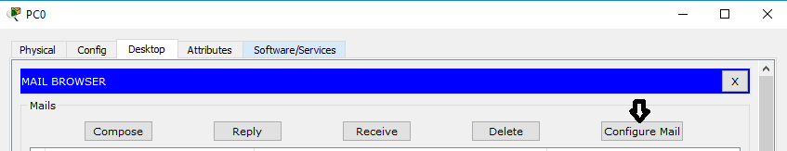

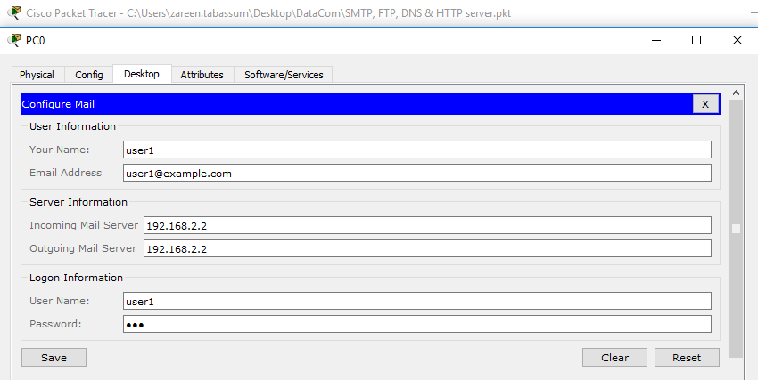

Do the same for PC1.

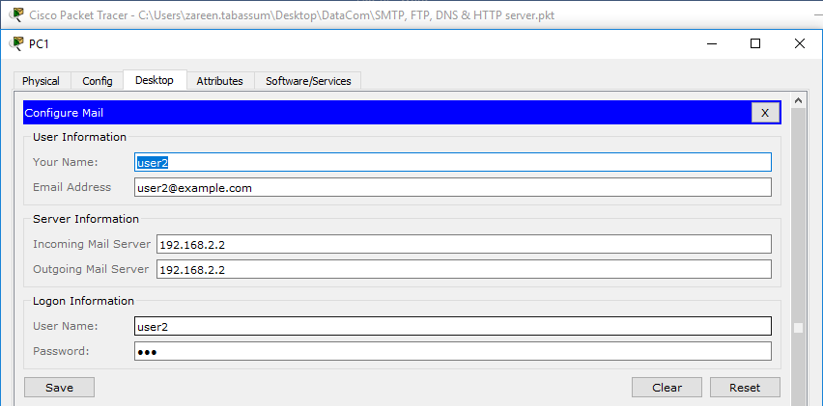

1. Now compose an email by again click on PC0 and go to Email and then press compose button.

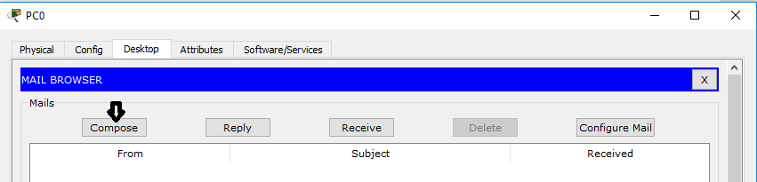

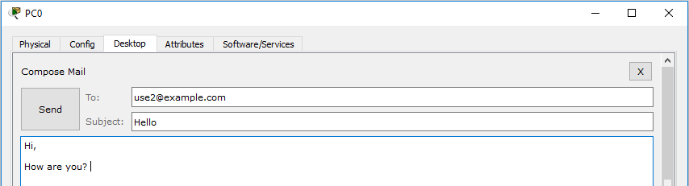

Send the email to user 2.

1. Check the email on PC1 by clicking on email and press receive button.

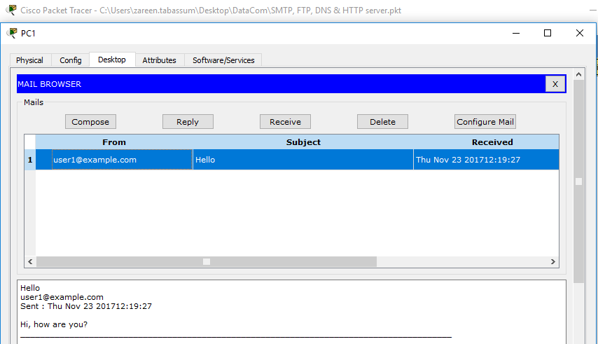

PC1 received an email from user1. Reply on this email and check on PC0 whether you receive reply from user2 or not. **Attach the screenshot of Email sent and received.**

| **MY NETWORK TOPOLOGY:  Setting up router:**  **Sending the email from PC0 to PC1:**  **Receiving the email from PC0 as PC1:**  **Replying the email as PC1 to PC0:**    **Receiving the reply from PC1 as PC0:**    **SUCCESSFUL!** |
| --- |

| **Task 2: Configure FTP server** | **[15]** |
| --- | --- |

**Steps:**

1. Click on FTP server and do the following configuration on FTP server (assign IP, subnet mask, gateway and DNS server)
2. Go to services in FTP server and click on FTP service from left side. “ON” the FTP service.
3. Add user name (user1) and their password in User Setup. Check on Read, Rename and list and click on Add.

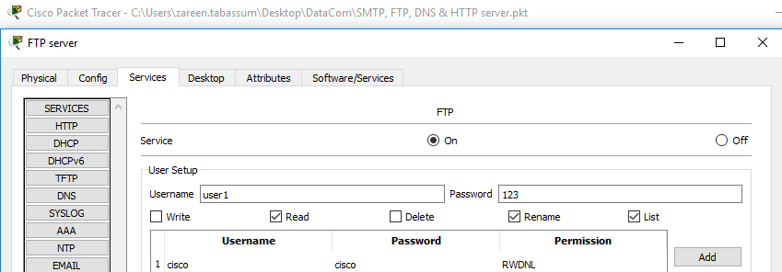

Similarly, add user2.

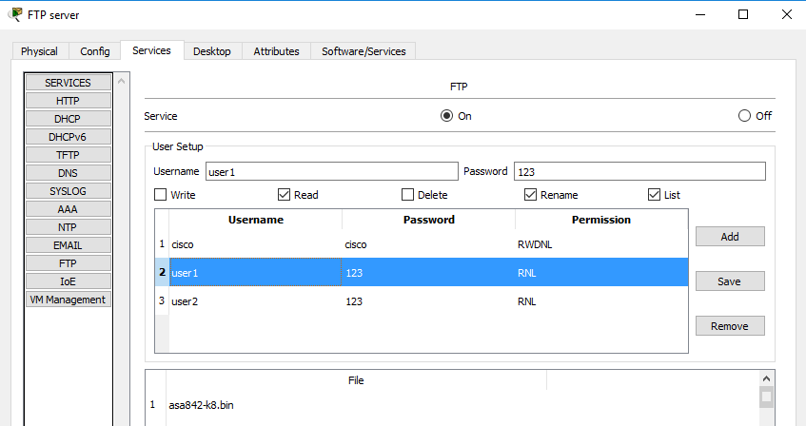

1. Open the command prompt on PC1. Check the directory of C using **dir**. Currently there is only file present in it as shown below.

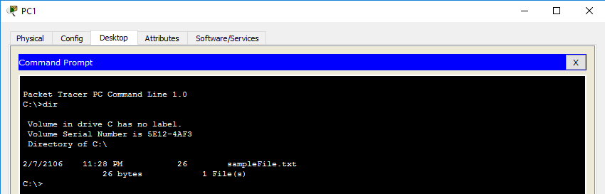

1. Ping FTP server (192.168.1.6) from PC1.

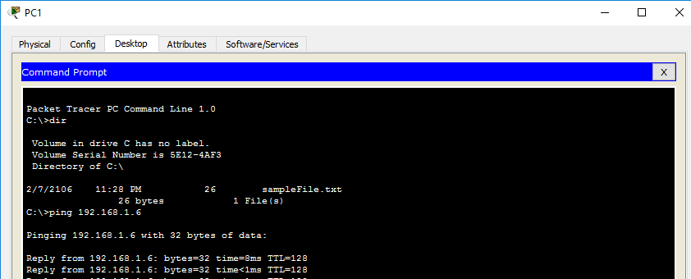

1. Type ftp 192.168.1.6. Enter user name (user2) and password (123).

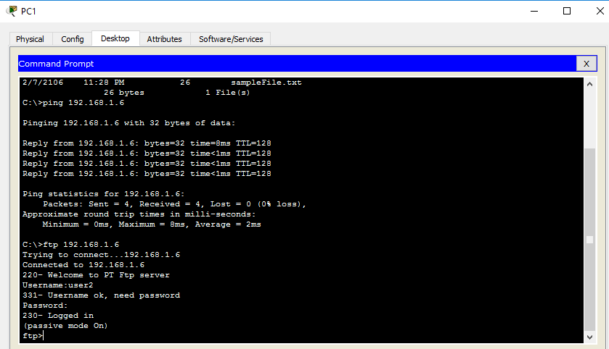

1. Write dir to check ftp directory from 192.168.1.6.

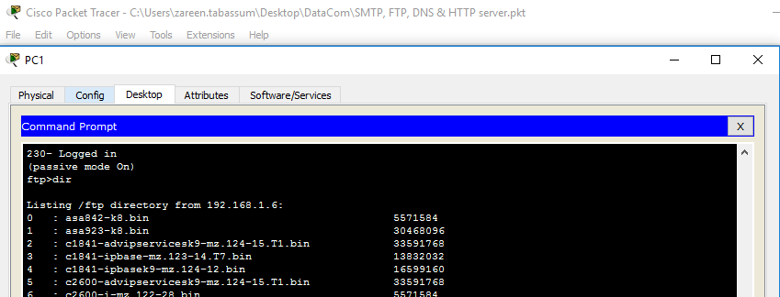

Transfer file (asa842-k8.bin) present on top using **get asa842-k8.bin** command.

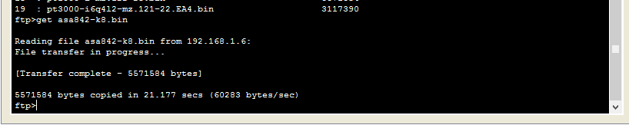

End the session by using quit command.

1. File (asa842-k8.bin) is successfully transferred to PC1. Verify by using dir command.

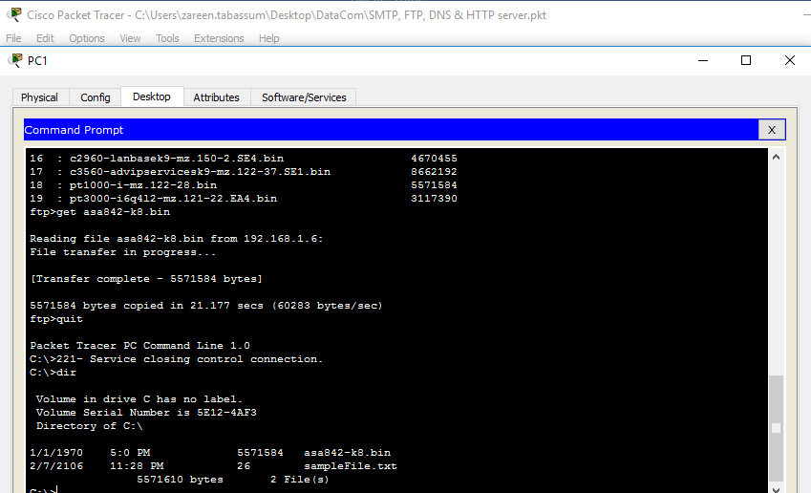

|  |
| --- |

| **Task 3: Configure HTTP & DNS Server** | **[20]** |
| --- | --- |

**Configure HTTP Server**

**Steps:**

1. Click on HTTP server and do the following configuration on HTTP server (assign IP, subnet mask and gateway) as shown below.
2. Go to services in HTTP server and click on HTTP service from left side. “ON” the service. Click on edit in index.html file.

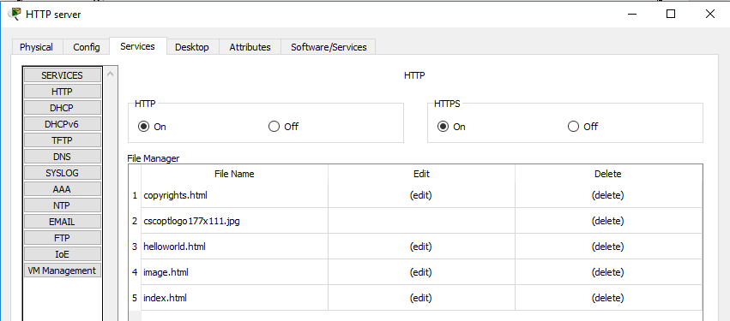

1. Write in Index.html file as I mentioned Welcome to Data Communication & Network Lab and save it.

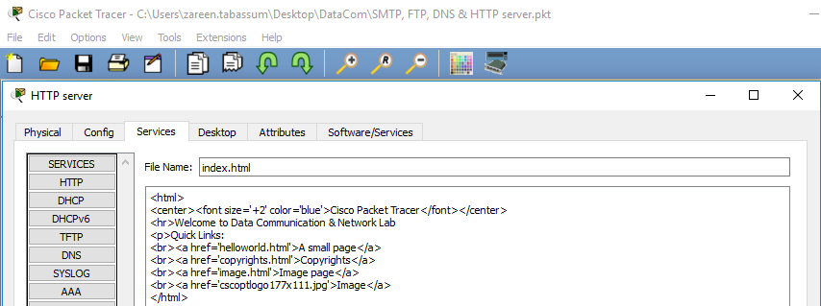

1. Open the web browser in PC0 or PC1 using http server IP and attach its screenshot below.

| **ANSWER:** |
| --- |

**Configure DNS server**

**Steps:**

1. Click on DNS server and do the following configuration on DNS server (assign IP, subnet mask, gateway and DNS server) as shown below.

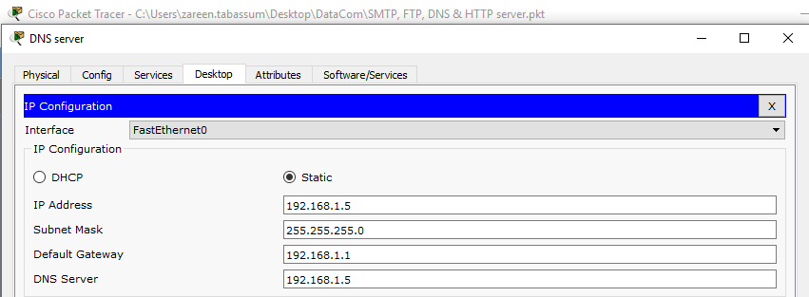

1. Go to services in DNS server and click on DNS service from left side. “ON” the service. Write [www.dcn.com](http://www.dcn.com/) in name and address 192.168.1.4. Press save button.

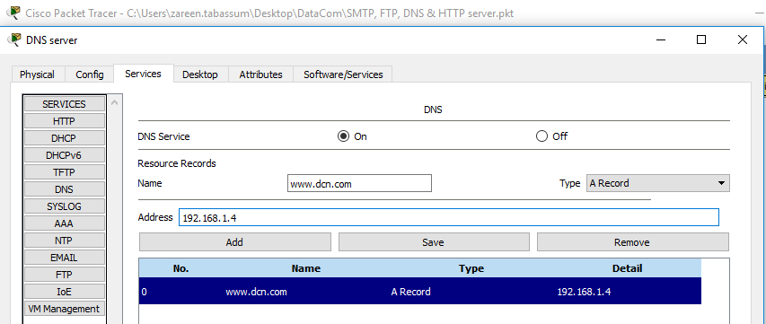

1. Open the web browser in PC0 or PC1. Type domain name (www.dcn.com) in URL location instead of IP and press enter.

| **ANSWER:** |
| --- |

**Task 4 : Post Lab Dynamically assign IPs by using Router**

**Steps:**

1. Go to CLI mode of Router0 and enter these commands as given below.

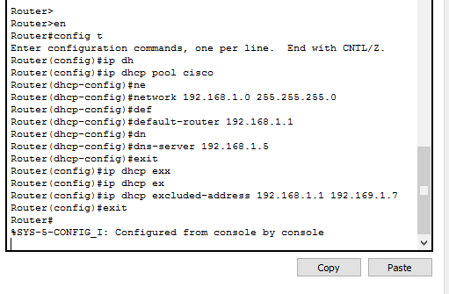

In the following command “ip dhcp pool cisco”, we are creating a pool for DHCP called cisco. cisco is the name here and we can name it whatever we want. Similarly, in the command “default-router “ we are telling the DHCP about the default route to follow.

Notice, after we exit from DHCP mode, we are excluding some IP addresses by applying this command “ip dhcp excluded-addresses x-x”, where x is the starting and ending IP address respectively. We are basically reserving some IPs for our use. It can be used to attach printers, or assign it to some specific users for security purposes. You can also give dns address in dhcp by using the following command. dns-server 192.168.1.5.

1. Now, Open the PC4. Click on IP configuration. Select from static to DHCP and after DHCP request is successful, note down IPs assigned to PC3, 4 and 5 by DHCP server.

| **Router Configuration:**  **PC3 Configuration:**  **PC4 Configuration:**  **PC5 Configuration:** |
| --- |

**Lab Evaluation Assessment Rubric**

**EE-424 Lab 11**

| **#** | **Assessment Elements** | **Level 1: Unsatisfactory**  **Points 0-1** | **Level 2: Developing**  **Points 2** | **Level 3: Good**  **Points 3** | **Level 4: Exemplary**  **Points 4** |
| --- | --- | --- | --- | --- | --- |
| **LR2** | **Program/Code/ Simulation Model/ Network Model** | Program/code/simulation model/network model does not implement the required functionality and has several errors. The student is not able to utilize even the basic tools of the software. | Program/code/simulation model/network model has some errors and does not produce completely accurate results. Student has limited command on the basic tools of the software. | Program/code/simulation model/network model gives correct output but not efficiently implemented or implemented by computationally complex routine. | Program/code/simulation /network model is efficiently implemented and gives correct output. Student has full command on the basic tools of the software. |
| **LR4** | **Data Collection** | Measurements are incomplete, inaccurate and imprecise. Observations are incomplete or not included. Symbols, units and significant figures are not included. | Measurements are somewhat inaccurate and imprecise. Observations are incomplete or vague. Major errors are there in using symbols, units and significant digits. | Measurements are mostly accurate. Observations are generally complete. Minor errors are present in using symbols, units and significant digits. | Measurements are both accurate and precise. Data collection is systematic. Observations are very thorough and include appropriate symbols, units and significant digits and task completed in due time. |
| **LR5** | **Results & Plots** | Figures/ graphs / tables are not developed or are poorly constructed with erroneous results. Titles, captions, units are not mentioned. Data is presented in an obscure manner. | Figures, graphs and tables are drawn but contain errors. Titles, captions, units are not accurate. Data presentation is not too clear. | All figures, graphs, tables are correctly drawn but contain minor errors or some of the details are missing. | Figures / graphs / tables are correctly drawn and appropriate titles/captions and proper units are mentioned. Data presentation is systematic. |
| **LR9** | **Report** | All the in-lab tasks are not included in report. | Most of the tasks are included in report but are not well explained. All the necessary figures / plots are not included. | Good summary of most of the in-lab tasks is included in report. The work is supported by figures and plots with explanations. | Detailed summary of the in-lab tasks is provided. All tasks are included and explained well. Data is presented clearly including all the necessary figures, plots and tables. |
| **AR4** | **\*Report Submission** | Late submission after 1 week and in between 2 weeks. | Late submission after 2 days and within a week. | Late submission after the lab timing and within 2 days of the due date. | Timely submission of the report and in the lab time. |

**\*Report:** Report will not be accepted after 1 week of due date